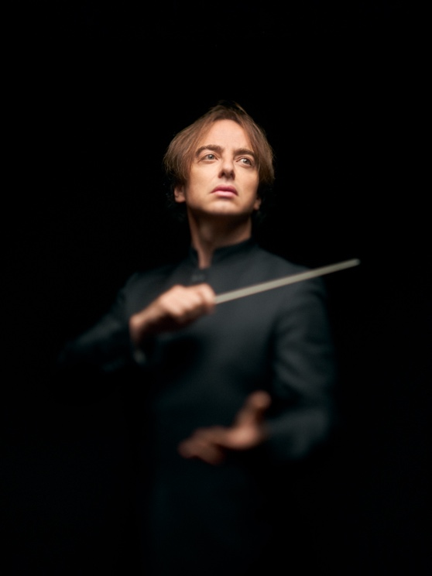
Jérémie Rhorer

Jérémie Rhorer burst onto the international music scene nearly twenty years ago with his irresistible interpretation of Mozart's operas. Since then, he has pursued his path between the operatic and symphonic repertoires, conducting both his ensemble, Le Cercle de l'Harmonie, and the orchestras that have invited him all over the world. An artist committed to defending his vision of music, which combines fidelity to the text, an intimate sense of drama and a spirit of freedom. For Jérémie Rhorer, the vibration of music engages our whole being: our body as well as our mind.

Jérémie Rhorer was already practising music at a high level as a child, as part of the Radio France Maîtrise. This was his first fundamental encounter with the voice and musical vibration, in contact with the likes of Jessye Norman, Colin Davies and Lorin Maazel. Drawn to conducting, he later studied with Emil Tchakarov, Karajan's renowned assistant. However, it is through composition, which he studied with Thierry Escaich, that Jérémie Rhorer fully embraced the profession of conductor. His intimate relationship with musical writing, its structure and emotion, is the hallmark of the great figures he admires such as Riccardo Muti, Carlos Kleiber and Leonard Bernstein, whose independence of spirit and musical power continue to inspire him today. Jérémie Rhorer continues to nurture this link with composition through the works he writes, but also by conducting the music of today, whether that of Thierry Escaich (Claude at the Opéra de Lyon or, more recently, Point d'orgue at the Théâtre des Champs-Elysées) or other contemporary composers.

Other key encounters in the conductor's career have been with Nikolaus Harnoncourt, whose ideas inspired him, and with William Christie, who gave him his first experience at the helm of his orchestra. Contact with period instruments proved to be a revelation: far from any ideology, for him it was first and foremost a sensitive approach to the truth of a work, through sound and experimentation, but also by returning to the text. Yet it was another era that he decided to explore in 2005 with his own ensemble, Le Cercle de l'Harmonie, a pioneer in the performance of the classical and romantic repertoire on period instruments.

With his musicians, Jérémie Rhorer explores the long road from Haydn and Mozart to Beethoven, Schumann, Brahms and now Bruckner. On the operatic side, the ensemble follows the chronological thread that links Gluck, Berlioz, Auber, Spontini and Cherubini, through to the great Romantic repertoire of Rossini, Donizetti, Verdi and soon Wagner. This is an invigorating reading of a repertoire that has sometimes been put to sleep by tradition: here the music rediscovers its original colours and its own theatricality, carried by the total commitment of both musicians and conductor, as demonstrated by their various recordings, particularly those of Mozart's great operas made for Alpha-Classics.

It is this strong, honest musical vision that has earned him invitations to Austria's Wiener Staatsoper, Theater an der Wien (Donizetti's Les Martyrs in 2023), the Amsterdam, Zurich, Turin and Rome opera houses, La Monnaie in Brussels, the Salzburg Festival, the Berlin Staatsoper (after replacing Daniel Barenboim in Beethoven's Missa solemnis at the Berlin Philharmonic in 2023) and Madrid's Teatro Real. In these different houses, he has conducted Mozart among other works, as well as Poulenc (for a unanimously acclaimed Dialogues des Carmélites with the Philharmonia orchestra), Weill, Schoenberg in Madrid and Venice, Richard Strauss in Paris and Aix-en-Provence, Verdi and Italian opera.

Called upon by symphony orchestras too, he explores the Germanic repertoire with the Leipzig Gewandhaus, French music with the Orchestre Symphonique de Montréal, pursues a Tchaikovsky cycle with the Deutsche Kammerphilharmonie Bremen (voted orchestra of the year at the 2023 Gramophone Classic Music Awards) and in 2023 makes his debut with the Accademia Santa Cecilia in Rome.

